Build Instructions for Robot Control Module

Using an ESP32 processor and L293D motor driver ICs

# Design:

Top view of finished board

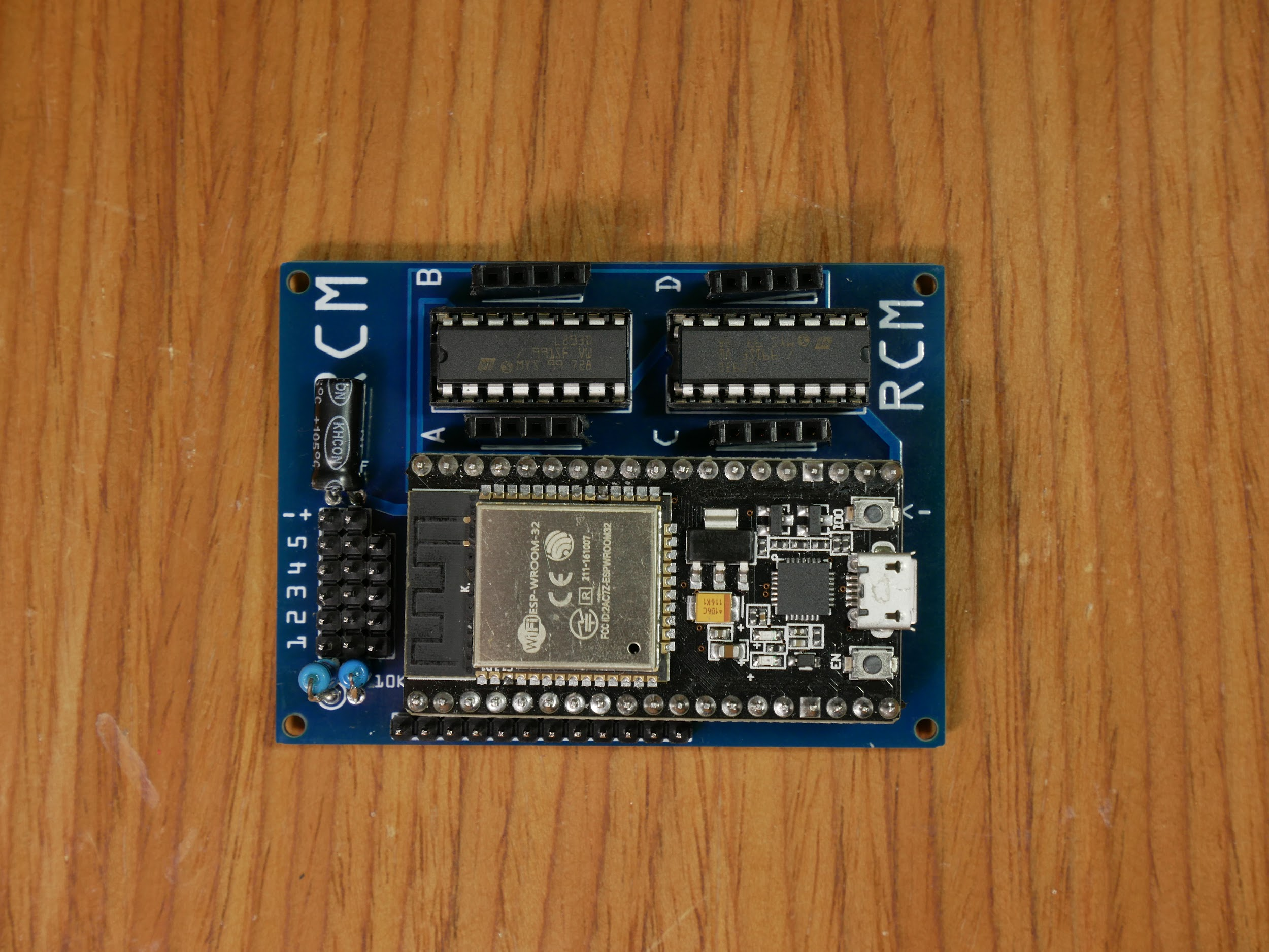

Bottom view of finished board (flipped like turning a page)

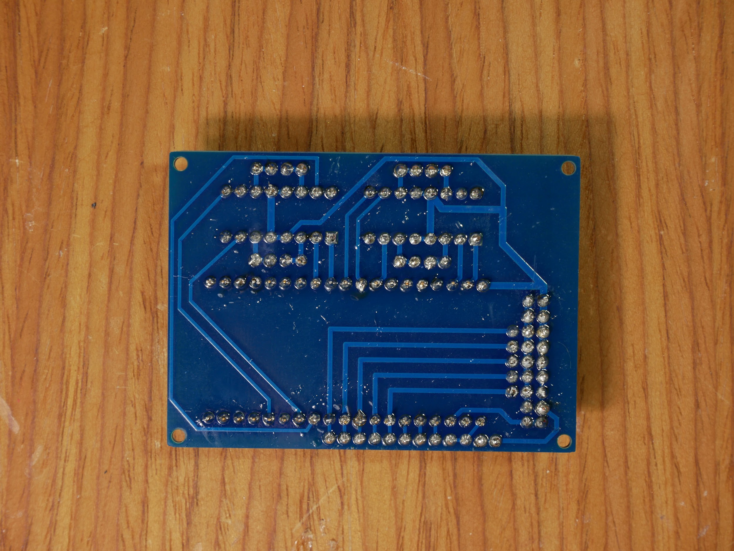

This picture shows the connections of the board. This is a top view of the board but shows the traces as if the board were see through.

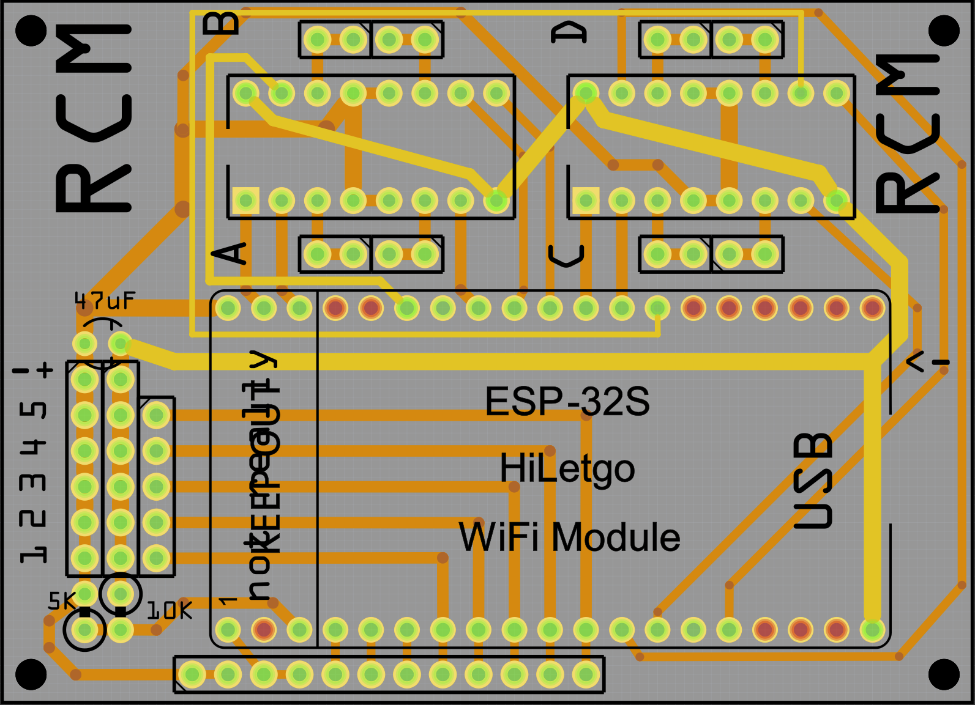

# **Parts:**

1 NodeMCU ESP-32s, it should have 38 pins

2 L293D motor driver chip

1 custom two layer circuit board

2x19,4x4 female header pins (quantity X number pins)

1x12,2x6,1x5 male header pins

2 16 pin IC sockets

1 47uf capacitor

1 5 KΩ resistor

1 10 KΩ resistor

0-4 small 6v geared motors (<600 mA)

0-5 micro servo motors

5 rechargeable NiMH AA batteries

1 5 AA bat holder

1 small switch for turning power on and off

# **Tools:**

Soldering iron

Solder

Needle nose pliers

Wire strippers

Flush cutters

Sandpaper (for sanding down edges of cut header pieces)

Fume extractor fan

Tape

# **Custom Circuit Board:**

[Here](https://drive.google.com/open?id=1SZ6mDr6fsBz-XyTxUaQjyDVLPNdf68HY) is the fritzing file for the board, and [here](https://drive.google.com/file/d/1jgYJGxwkeENqHsrdX3ExyqwmSFj0cndf/view?usp=sharing) are the exported gerber files for the board.

When exporting for your router or custom pcb service, make sure that the board will end up like in the photos above and not mirrored.

# **Build:**

Orient the circuit board as shown.

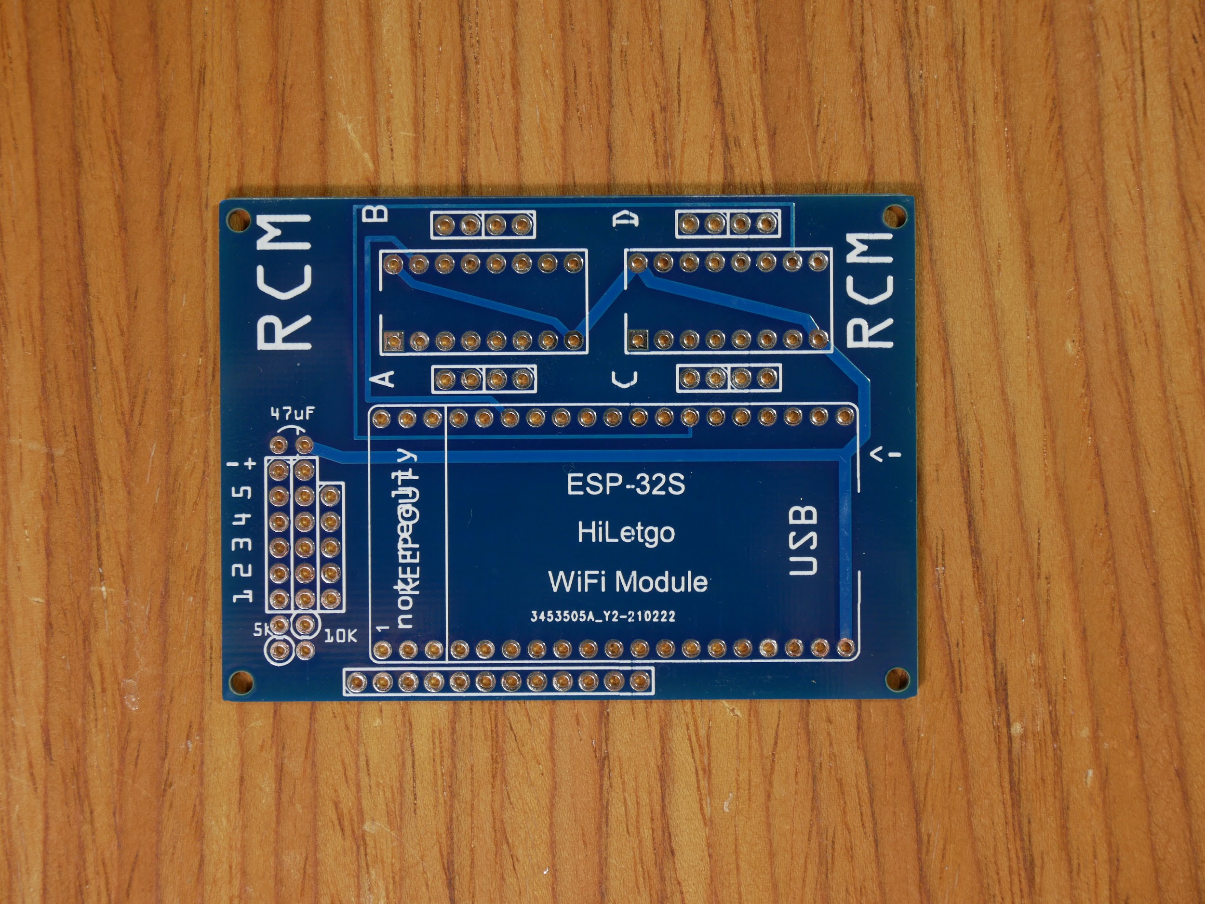

Solder the two resistors to the board as shown in the picture. The resistor on the left should be 5 KΩ and the one on the right should be 10 KΩ.

[picture]

Solder the 47 uF capacitor to the board as shown in the picture. The negative wire of the capacitor (it’s on the side marked with a stripe, and it’s the shorter wire) needs to go in the left hole.

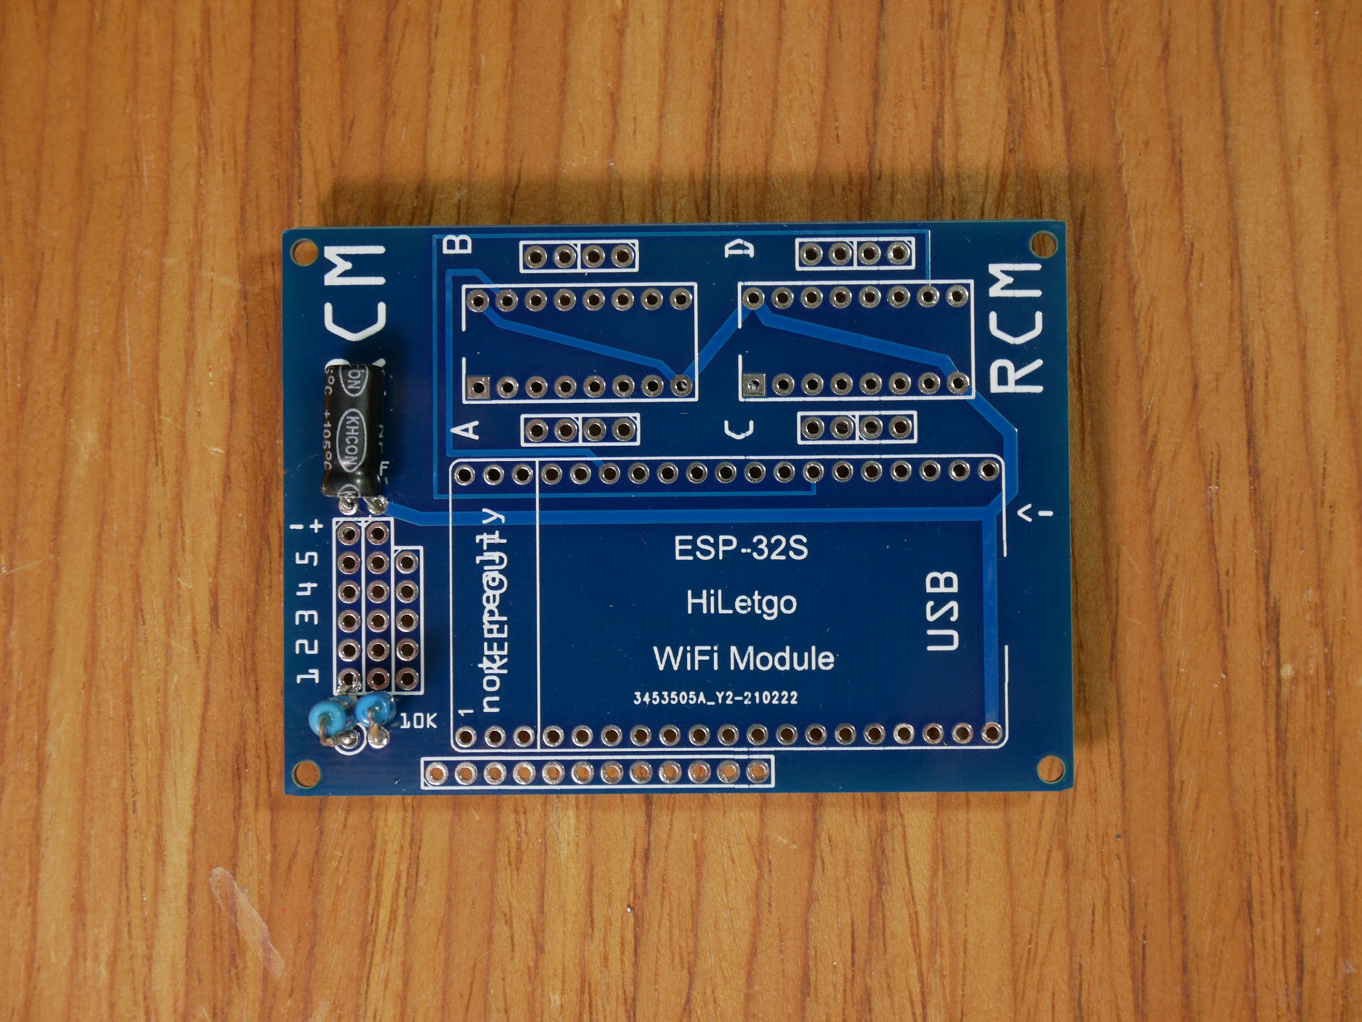

*Use tape to secure each part to the board so it won’t fall out when you turn the board over to solder. Make sure everything stays at right angles and flush to the board since if pins are soldered at an angle it will be hard to plug into them later. You can place and solder parts one at a time if you find that easier.*

Place the remaining components in the board as shown below and solder every pin.

*It may be easiest to first add the 2 16 pin sockets and all male pins, then add all 4 sets of 4 female pins, and finally add the 2 large strips of female headers which hold the esp32.*

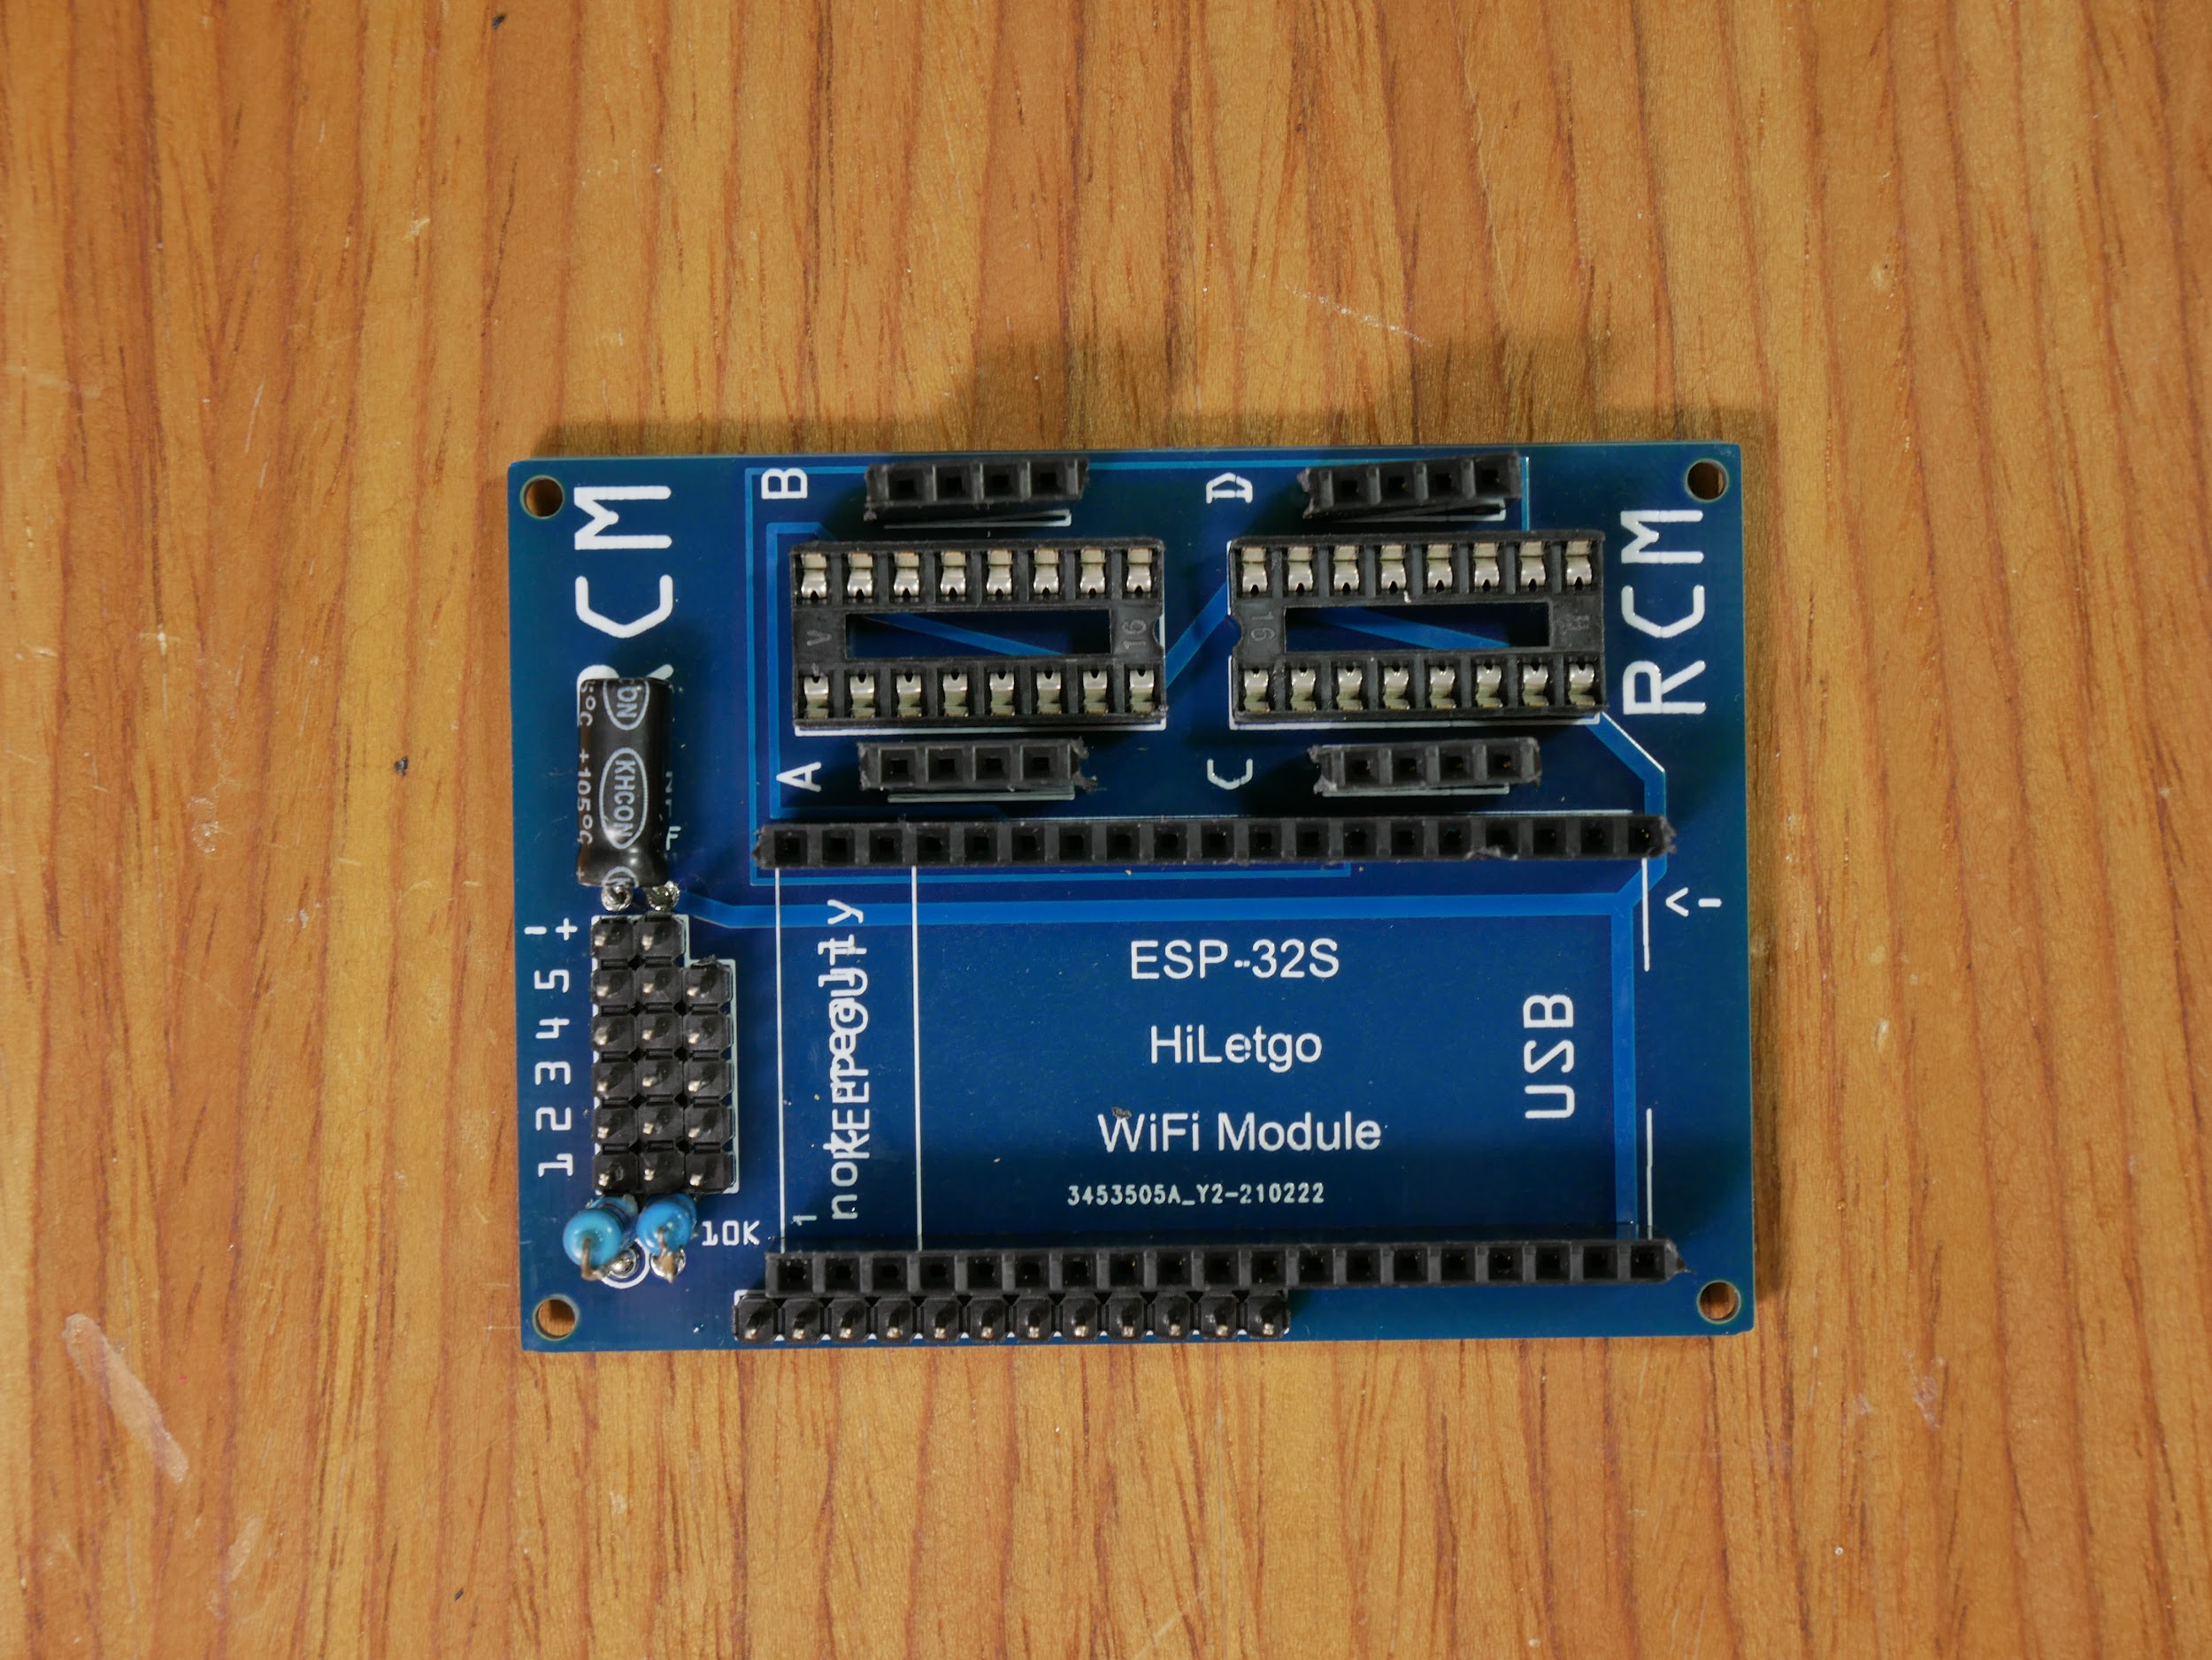

*If two pins get bridged by solder that aren’t connected with a copper (lighter color showing through board color) trace, you need to disconnect them (try melting the bridge with the soldering iron and “cutting” the blob with the tip of the iron.*

Trim any wires or pins that stick out too far on the back.

Plug in the ESP32 and the L293D chips. The orientation of the ESP32 should be as in the photo, the orientation of the driver chips doesn’t matter.



Add female pins to the battery pack wires and add the power switch to one of the wires.

[picture]

Solder solid core wire or male headers to the motors so they can be plugged in.

[picture?]

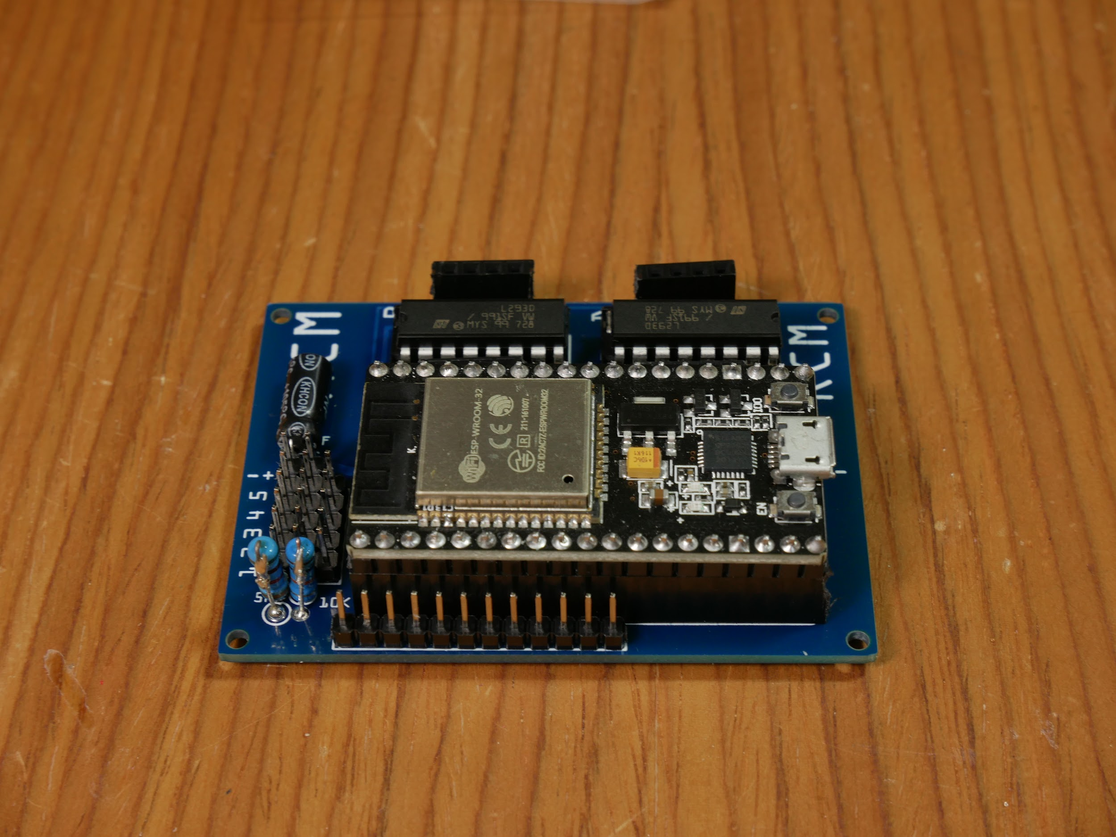

YOU’RE DONE BUILDING THE RCM!

# 

# **Programming:**

## Upload Code to RCM:

<https://github.com/rcmgames/rcm> (look at branches for examples)

## Install Driver Station App:

<https://github.com/rcmgames/RCMDS-new> (recommended)

<https://github.com/rcmgames/RCMDS> (advanced)

[RCM user guide](https://drive.google.com/open?id=12HUcpWKluF6-3oLMwZiLKZ4KrxwmTE_D)